Lane

Lane Maintenance
This page contains all your lanes (origin / destination pairs) for every combination for this legal entity.
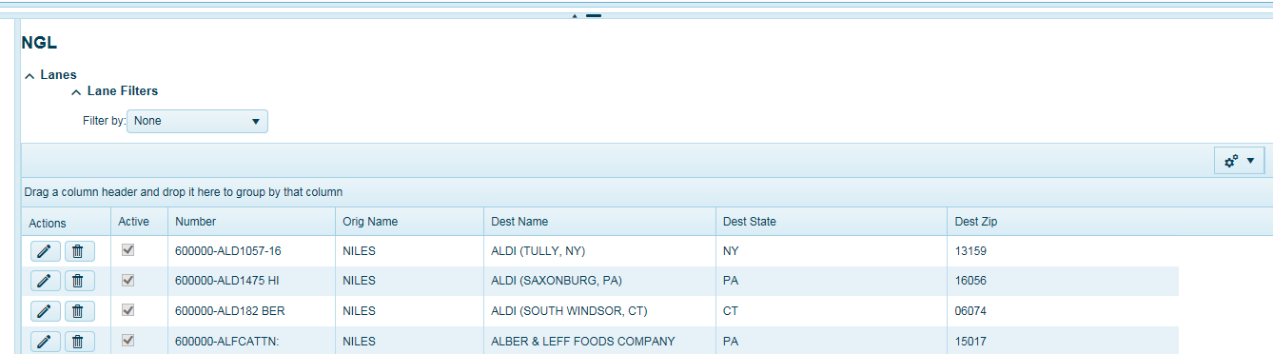

Click on the pencil icon to edit or review more detailed information regarding this lane.
Delivery notes are default comments that are typically static for every shipment, for example Call for delivery appointment 24hrs. in advance. Users can add notes that will be sent to carriers upon tender. Delivery Notes will appear on the TMS BOL.
Confidential comments are for internal eyes only and will not be shared outside of TMS or with any carrier.
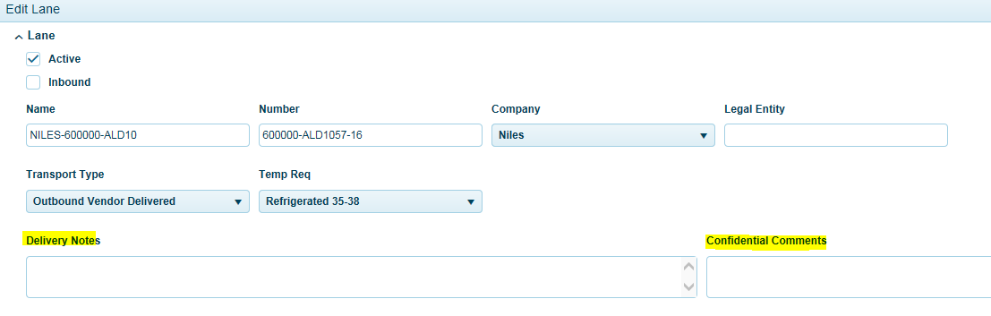
Depending on your TMS configuration the only recommended changes that should be made are the contacts, dock hours, phone, and email address. Please contact your support team before you change any other fields. Name and Number should never be changed.

If a lane is an Inbound lane (Vendor to your location) the box should be checked to indicate this is an Inbound lane. This should happen automatically unless a manual lane was created.
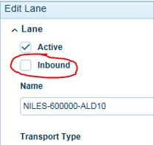
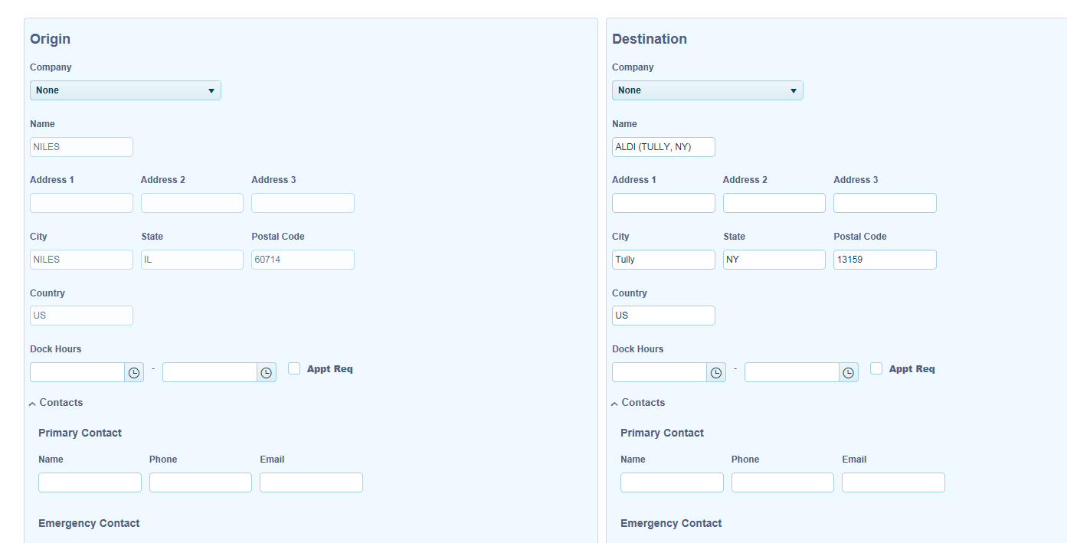
When using LTL carrier API’s some default information is required to be populated upon dispatching for both the origin location and destination location such as contact, phone, and email address. Be sure this information is maintained accordingly. Users will have a chance to enter this information prior to dispatching. When entered on the lane, the system will use this information as default for each order.
The system by default will look to the order for this information. If Origin information is missing the system will look for this information in the lane origin. If missing, the system will use the defaulted contact for company location contact name, email, and phone.
If defaulted Destination contact information is missing, users will need to populate at time of dispatching.
